|  |
| --- |
|  |
| December 2020 |
|  |

Florenceville Middle School



# Upcoming Events

**December 2020**

2nd - Newsletter

3rd – Evening Parent Teacher

4th – Morning Parent Teacher – NO School for students

18th – Last Day of School

**January 2021**

4th – First day back to school

6th – School Newsletter

|  |
| --- |
|  |
| **Physical Education and Being Prepared!**  Many students are not coming to school prepared for Physical Education with indoor shoes. It is necessary for them to have indoor sneakers that not only keep our gym floors much cleaner, but also allow them to move properly during PE class.  Thank you! |

Gly

8794 Main Street, Florenceville-Bristol, NB E7L-3G2

FMS.nbed.nb.ca 506-392-5115

|  |
| --- |
|  |
| The calendar reads December, but the weather is more like October!  Thank you so much for everyone who supported our fundraising efforts with the poinsettia and Christmas flower campaign. The plants were big, full, and beautiful! With this fundraiser, we raised $3405. Monies from fundraisers such as this help to offset the costs associated with athletics, school performances, student activities and trips. Any leftover funds are used for all other educational purposes. We look forward to collaborating with Jolly Farmer again in the spring for our spring flowers, which are always a huge hit!  Don’t forget – pick up is tonight, December 2nd, beginning at 5pm. The student who collected the orders are to pick up the whole order and ensure delivery – we appreciate your support in this. Please enter the McCain side of the building, travel around the back, and you will see the pickup station at the back door!  THANK YOU! |
|  |

## **Sports teams**

Badminton season is wrapping up, and even with the changes to reduce contact our students are having fun! Thank you to Mr. Black, Mrs. Pelkey, and Mme Sanders for supporting our students as coaches!

Basketball will begin after the Christmas break – stay tuned for more info!

## **Book Fair**

Don’t forget! The FMS Virtual Book Fair ends on December 4th! The unique FMS online shopping link is: https://bookfairs-canada.myshopify.com/pages/5152209

## **Keeping Families informed**

Thank you for continuing to listen to School Connects messages and emails, as well as connecting with your child’s teachers. We appreciate that you spend some time attending to these, as well as reading through the newsletter when it arrives. Our Home and School also keeps their Facebook page updated with things to know – please remember, if you need to ask someone here at FMS a question related to school, call us at 392-5115 or send an email as opposed to messaging on the Home and School Facebook page. Thanks for taking the initiative in keeping informed!

Don’t forget that parent teacher interviews will be held this week! Call the office to book a phone call or Microsoft Teams meeting with your child’s teacher for Thursday evening, December 3rd and Friday morning, December 4th.

We wish you a joyous holiday season with family and friends! Merry Christmas, and Happy New Year!

## Student Screening

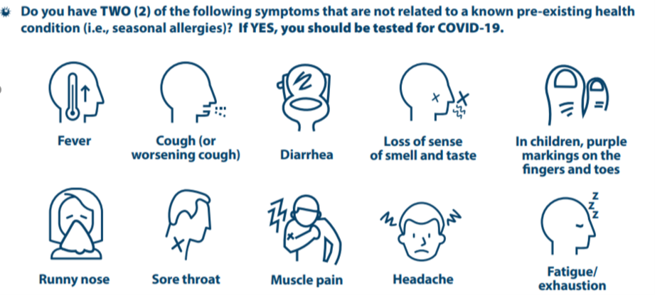Don’t forget! If students are experiencing 2 of the symptoms listed, call 811 for further information.

If your child is at school and presents with 2 or more symptoms, you will be required to pick them up within the hour and contact 811. Thank you!

## Fostering resilience

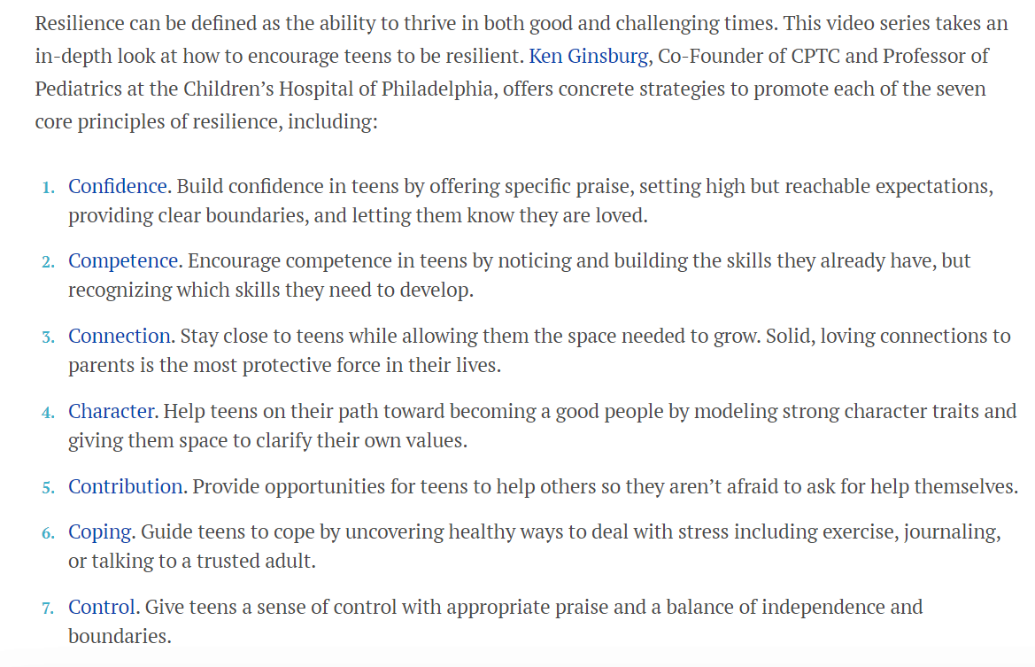

For more information, visit <https://parentandteen.com/resilience-videos/>

## FMS Happenings

Even though we are mid-Pandemic that has many regulations impacting our school, there are lots of positives to celebrate!

We hosted our first Virtual Assembly today, completely student directed! Thank you so much for Mme Frenette and her homeroom for taking on and meeting this challenge!

Students have been focused on social emotional learning in our PDCP block that happens twice per week, as well as during our homeroom blocks. Last month, the focus was on Forgiveness, and students are learning all about the trait of Patience this month. Take a few moments to chat with them about these themes and their learning.

We continue to look for ways to celebrate, even though we are in an Orange zone. Upcoming class activities will be our focus for last couple of days before the break.